INVOICE PARSER ROJECT REPORT
Name: Rithan Koushik K
Employee id: 9997652
Organization: SACHA GLOBAL
Domain: Invoice parser
Date: 13.02.2026
Day-wise Learning Summary
Day 1
  - Understood the business problem of manual invoice processing and the need for automation.
  - Analyzed different invoice formats (PDF, images, DOCX) and identified challenges in extracting structured data.
  - Designed the end-to-end system architecture for an AI-powered invoice parsing pipeline.
  - Finalized a modular workflow consisting of:
    - Document ingestion
    - OCR-based text extraction
    - LLM-based semantic parsing
    - Structured JSON validation
    - Automated data upload
  - Created a scalable project folder structure suitable for future extensions.
Day 2
- Implemented document type detection for PDF, image, and DOCX invoices.
- Integrated EasyOCR for extracting text from image-based invoices.
- Used pdf2image to convert PDF pages into images for consistent OCR processing.
- Used python-docx to extract text from DOCX invoices.
- Standardized OCR output into a unified text format for downstream processing.
- Tested OCR performance on multiple invoice layouts.

Day 3
- Designed structured prompt engineering for invoice field extraction.
- Integrated a lightweight instruction-tuned LLM to convert raw invoice text into structured JSON.
- Enforced strict JSON-only output without markdown or explanations.
- Extracted key invoice fields such as:
- Invoice number, dates, vendor details
- Customer information
- Subtotal, tax, total amount, currency
Day 4
Crash Course: Docker for Absolute Beginners
- Learned Docker fundamentals: images, containers, Dockerfiles.
- Understood containerizing Python applications for consistent environments.
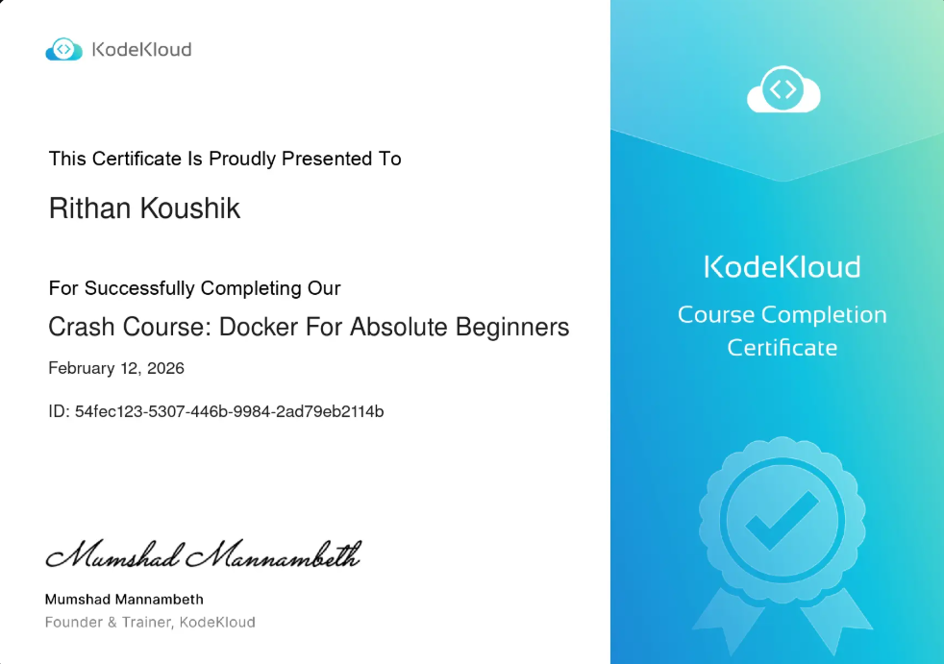
- Gained clarity on how Docker can simplify AI deployment.

Git for Beginners
- Learned Git basics: repositories, commits, branches, push/pull.
- Used Git for version control throughout the project.
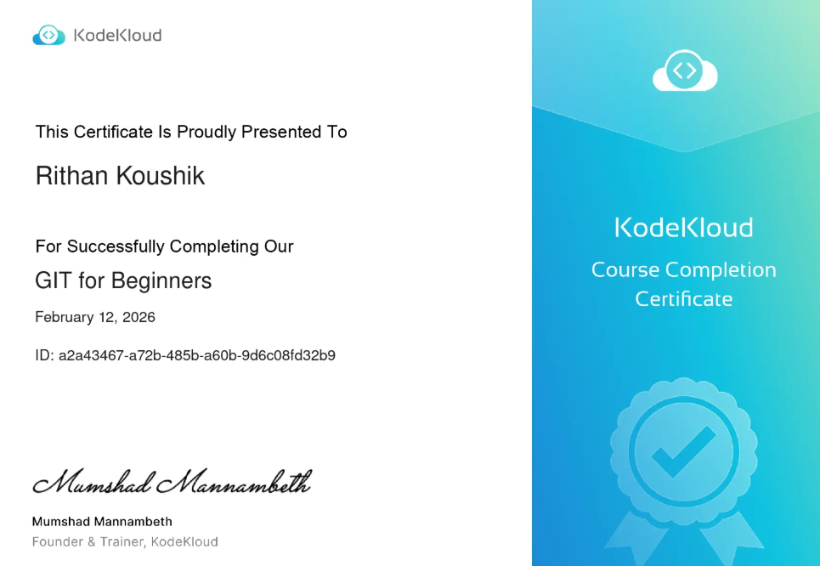
- Understood handling sensitive files using git.

Jenkins for Beginners (KodeKloud)
- Learned CI/CD fundamentals and Jenkins pipeline concepts.
- Understood how Jenkins can automate testing and deployment.
- Gained exposure to integrating ML/AI projects into CI pipelines.
Day 5
- Implemented structured JSON validation and data cleaning.
- Normalized numeric fields such as subtotal, tax, and total amount.
- Integrated automated data upload to cloud storage (Google Sheets / SharePoint-ready architecture).

INVOICE PARSER AND AUTOMATE DATA UPLOAD
- INTRODUCTION
In modern business environments, invoice processing plays a critical role in financial management and compliance. Organizations receive invoices in multiple formats such as PDF, images, and DOCX files, which often require manual review and data entry into accounting systems. This manual process is time-consuming, prone to human error, and inefficient at scale. The AI-Powered Invoice Parsing System is designed to automate the extraction of structured financial information from unstructured invoice documents. By leveraging OCR techniques and a lightweight instruction-tuned Large Language Model (LLM) running locally, the system converts raw invoice content into validated JSON output and integrates it directly with Google Sheets for structured storage.
- PROBLEM STATEMENT
There is a need for a cost-effective, privacy-preserving, and scalable solution that can accurately interpret diverse invoice formats using semantic understanding rather than static rules. The system must support multi-format input, generate strictly structured financial data, validate numerical fields, and integrate seamlessly with enterprise storage systems such as Google Sheets — all while maintaining offline processing capability for OCR and LLM inference..
- DATASET DESCRIPTION
The dataset used for this project consists of sample invoice documents in multiple formats, including PDF, PNG/JPG images, and DOCX files. These invoices represent typical Indian GST-based billing structures containing fields such as invoice number, vendor details, GSTIN, tax breakdown, subtotal, and total amount. The dataset includes invoices with varying layouts and formatting styles to ensure the system is capable of handling real-world document variability and testing the robustness of OCR and LLM-based semantic extraction.
- METHODOLOGY
The system follows a modular pipeline for automated invoice processing. Initially, the uploaded document (PDF or image) is processed to extract raw text. For image-based invoices, EasyOCR is used to perform optical character recognition, while PDFs are converted to images before OCR processing to ensure consistent text extraction.

The extracted raw text is then sent to the Groq API, where a lightweight instruction-tuned language model performs semantic parsing to identify and extract structured invoice fields in strict JSON format. Finally, the structured output is validated and cleaned before being stored or further integrated, completing the end-to-end automated invoice parsing workflow.
MODEL USED:
The system uses the llama-3.1-8b-instant model via the Groq API for semantic invoice parsing and structured data extraction. This is a lightweight 8-billion parameter instruction-tuned Large Language Model optimized for fast inference and low latency. It is particularly suitable for structured prompt-based tasks such as JSON generation, field extraction, and controlled output formatting. The model enables accurate semantic understanding of invoice text without relying on rule-based or regex-based parsing methods, ensuring adaptability across diverse invoice layouts while maintaining efficient performance. The system uses EasyOCR as the Optical Character Recognition (OCR) engine for extracting text from image-based invoices. EasyOCR is an open-source deep learning-based OCR library that supports multilingual text recognition and works effectively on scanned documents with varying layouts. It uses convolutional neural networks (CNN) and sequence modeling techniques to accurately detect and recognize text regions within images.
- RESULT
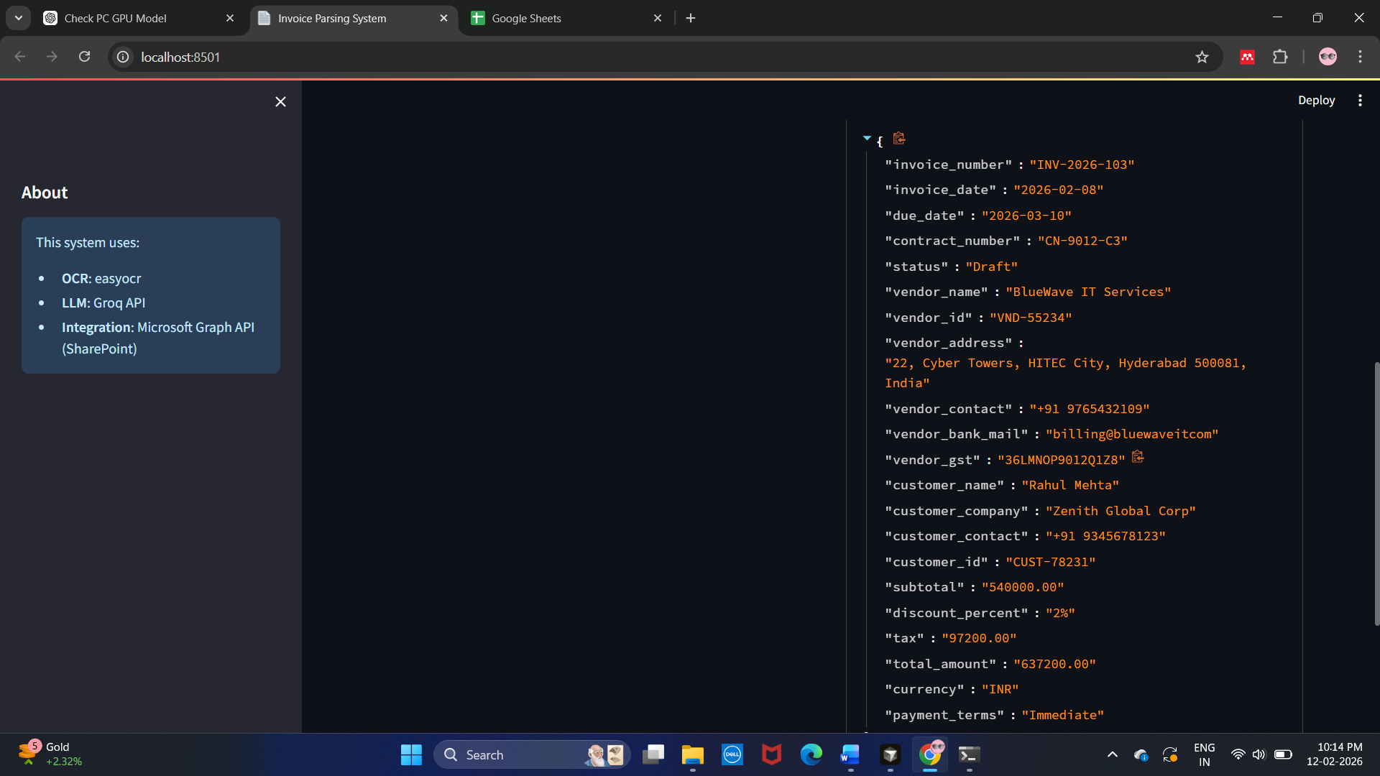

FIG 3. Invoice parsed and returned as json
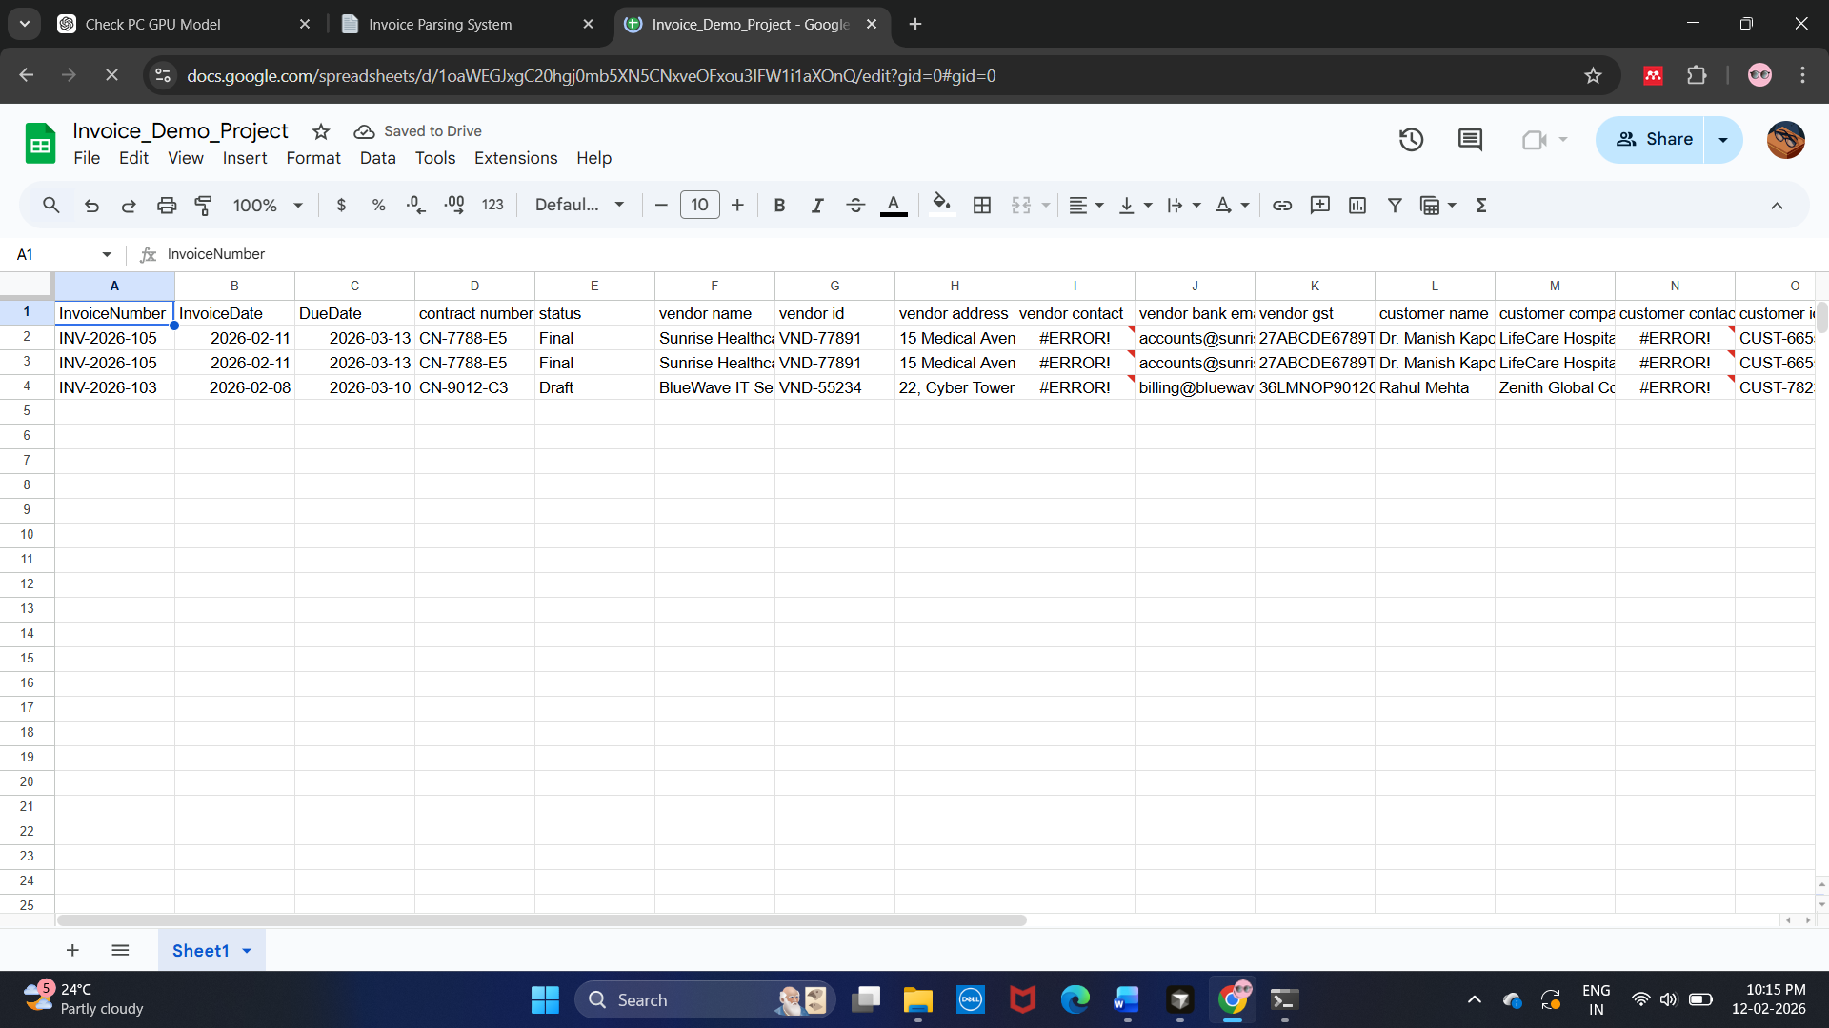
FIG 4. Retrieved fields stored in google sheets
- TOOLS USED
- Python
- VS CODE
- EasyOCR
- Groq API - llama-3.1-8b-instant
- pdf2image
- Pillow (PIL)
- gspread
- Google Sheets API
- CONCLUSION
The AI-Powered Invoice Parsing System successfully demonstrates an end-to-end automated pipeline for converting unstructured invoice documents into structured, validated financial data. By combining EasyOCR for text extraction and the llama-3.1-8b-instant model via the Groq API for semantic parsing, the system achieves flexible and layout-independent invoice understanding without relying on rule-based methods. The integration with Google Sheets further enables real-time structured data storage, making the solution practical for business workflows. Overall, the project highlights the effective application of OCR and lightweight LLM technologies in building scalable, cost-efficient, and automation-ready document intelligence systems.

